# Mathematics Essential

# Name: ____Solutions_____________

## Task 2.5 – Unit 2

**Assessment type:** Response - Skills

**Conditions:**

Time for the task: 30 minutes

In class, calculator permitted

**Marks:**  marks ______/ 34

**Task weighting:**

2% of the school mark for this unit

_____________________________________________________________________________

**Question 1:**

1. ½ of 60 30
2. 0.5 x 120 60
3. 1.25 hrs = ___75_____ mins
4. Write ¼ as a decimal 0.25
5. 0.25 hours = __15____ mins
6. 45 mins = ___0.75___ hours
7. A fortnight = ____14______ days
8. October has ___31______days
9. 5% of 450 22.5
10. Simplify the ratio 4:12 1:3

**Question 2:**

Convert the following to 24hour time

1. 1.30 am 0130
2. 10.14 pm 2214
3. 3.07 pm 1507
4. 2.22 pm 1422
5. 12.10 am 0010

**Question 3:**

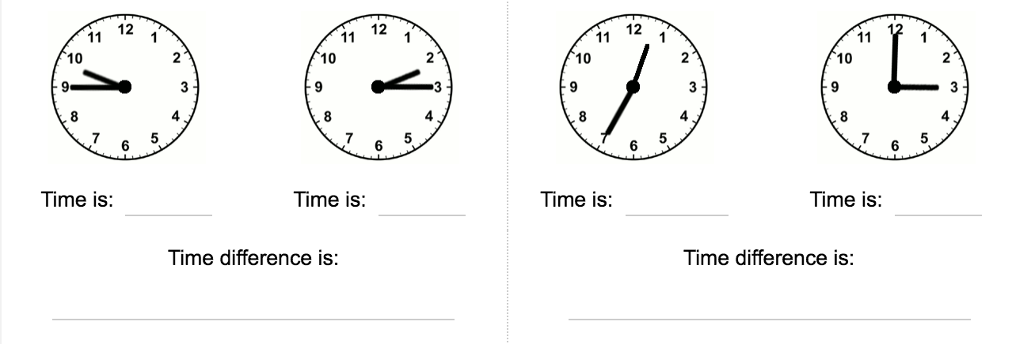

1hrs 25 mins

4hrs 30 mins

12.35

3.00

2 15

9.45

**Question 4:**

***Write the differences between the two times***

1. 1:35 p.m. and 5:40 p.m.

4 hrs 5 mins

1. 8:45 a.m. and 11:20 a.m.

2 hr 35 mins

**Question 6:**

If Noah takes a group of friends to the movies for his birthday, it would cost $62.50 for five tickets, how much would it cost if there were 12 people (including Noah) in the group?

$150

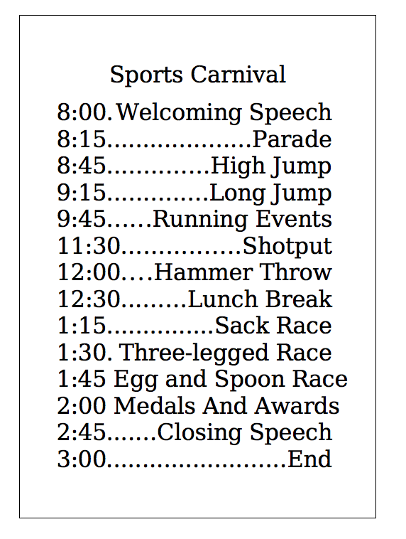**Question 7:** From the timetable below calculate the following

1. Is the Welcoming Speech the same length as the closing speech? Yes
2. How long is the Parade? 30 mins
3. How long is the Lunch Break? 1 hr 45 mins
4. Which events are half an hour long? High Jump, Long Jump, Shot Put, Hammer Throw,
5. How much time will the running events take? 45 mins
6. How many hours long is the carnival? 7 hrs
7. It takes Mrs Jones two and a half hours to get to the school from work. What time should she leave work, if she wants to arrive in time to watch her son and daughter receive their medals? 11.30am